

**ATAR Chemistry 11 Unit 1 Task 2 NAME: _____________________**

**Atomic Structure and Mass Spectrometry test**

(Total 42 marks)

1. a) State the two forces in the nucleus and which particles they act on. [ 2 marks]

_______________________________________________________________________

________________________________________________________________________

_________________________________________________________________________

b) Explain how the nucleus stays together [ 2 marks] _______________________________________________________________________

________________________________________________________________________

_________________________________________________________________________

c) Explain how the atom stays together [2 marks]

_______________________________________________________________________

________________________________________________________________________

_________________________________________________________________________

2. [11 marks]

|  |  |  |  |  |  |  |
| --- | --- | --- | --- | --- | --- | --- |
| Name | Symbol | Atomic number | Mass number | Protons | Neutrons | Electrons |
| Oxygen 17 | 17O |  |  |  |  |  |
| Chlorine 35 |  |  |  |  |  |  |
|  |  |  |  | 16 |  |  |
|  |  | 82 | 207 |  |  |  |

3. Write the symbol for the following atoms. [8 marks]

a) lithium_________ e) potassium __________

b) Lead _________ f) Silver ___________

c) Iron ________ f) Barium ____________

d) sodium __________ g) Beryllium ___________

4. Name the following: (6 marks)

a) Ca ____________ b) Cr ___________

c) Cu ___________ d) Al____________

e) K ____________ h) Mn __________

5 (4 marks)

The mass spectrum for a sample of copper is shown below.

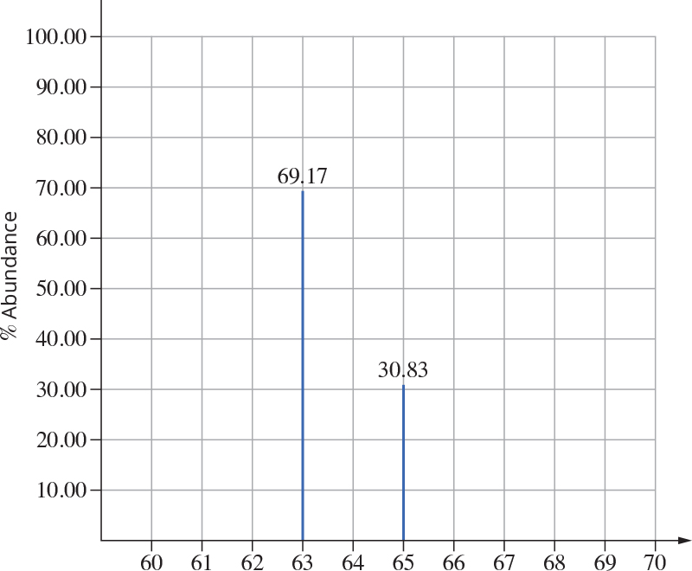

a Label the x-axis of the mass spectrum. (1 mark)

b From this data determine the RAM (relative atomic mass) for copper. Show all working.

(3 marks)

______________________________________________________________________

_____________________________________________________________________

______________________________________________________________________

______________________________________________________________________

______________________________________________________________________

6. Explain precisely what isotopes of an element are. [ 2 mark]

_______________________________________________________________________

________________________________________________________________________

_________________________________________________________________________

7. Explain the function of the following parts of the mass spectrometer: ( 4 marks)

a)

Vaporisation: ________________________________________________________________

Electron scattering: *____________________________________________________________*

Electric field: *______________________________________________________________________*

Magnetic field: *____________________________________________________________________*

1. How is the mass determined? [1 marks]

_______________________________________________________________________

________________________________________________________________________

_________________________________________________________________________